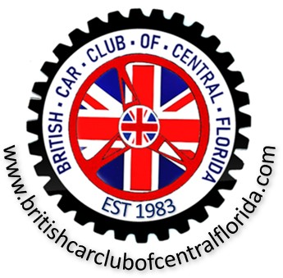
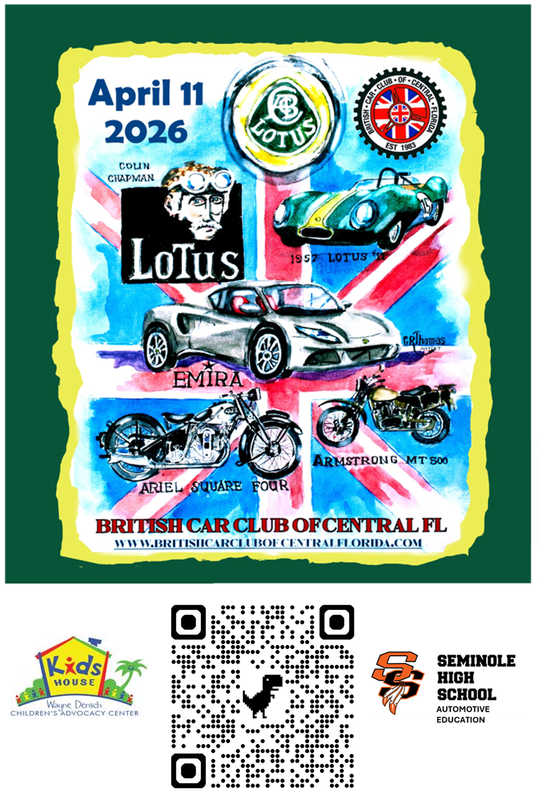
41st Annual All British Car & Motorcycle Show and Weekend Activities
April 10th, 11th and 12th, 2026
Henry’s Depot – Sanford, FL

The British Car Club of Central Florida appreciates your support

Sponsor Application

Note: British Car Club of Central Florida is a registered and qualified Florida Not for Profit organization (501C7). Your sponsorship may be tax deductible. Check with your financial advisor.

SPONSORSHIP LEVELS
Platinum $ 1,000
Gold $ 500
Silver $ 250
Bronze $ 150

Company Name ____________________________________________________

Address ___________________________________________________________

City __________________________State __________________ Zip _____ __

Phone _________________ Email _________________________ ___

Website ___________________________________________________________

Contact ___________________________________________________________

Type of Sponsorship: check one

□ Platinum □ Gold □ Silver □ Bronze □ Show Event Sponsor

The club estimates that promotion for the April 11th 2026, show will commence prior to January 2026 with regular emails to individuals, participating clubs, sponsors and vendors. We strongly suggest that you return this form with your payment to maximize the visibility of your sponsorship.

If Paying by Check: Make Checks Payable to:

British Car Club of Central Florida Inc.
1306 East Lansdowne Ave
Orange City, FL 32763

If Paying By Credit Card:

Name on Card: ___________________________________________________

Card Number: ____________________________________________________

Expiration Date: __________________________________________________

CVC Number: ____________________________________________________

Your credit card statement will show a payment to British Car Club of Central Florida. Credit card information will NOT be kept on file. This is a one-time only purchase.

Should you have any questions, please contact:

Les Neumann at britcarclubcentralfl@gmail.com

Or visit our website at: britishcarclubofcentralflorida.com

Sponsor Opportunities for the 2025 40th Annual
All British Car & Motorcycle Show

Platinum Sponsor - $1,000
- Your logo on masthead of our website
- Your logo on all emails and posters
- Your logo (large) on show T-shirt
- Set up your 10 x 10 tent on the show field
- 2 show T-shirts

Gold Sponsor - $500
- Your logo on all emails and posters
- Your logo (large) on show T-shirt
- Your logo on sponsor page of our website
- Set up your 10 x 10 tent on the show field
- 2 show T-shirts

Silver Sponsor - $250
- Your logo (small) on show T-shirt
- Your logo on sponsor page of our website
- Set up your 10 x 10 tent on the show field
- 2 show T-shirts

Bronze Sponsor - $150
- Your logo on sponsor page of our website
- Set up your 10 x 10 tent on show field

You may also want to sponsor specific show events:
- Friday (April 4) Evening Meet & Greet at the Comfort Inn - $500
  - Recognition on all signs, banners and emails
- Best in Show Trophy - $250
  - Your logo and club logo on the trophy
- First Place Marque Trophy - $100 per marque
  - Your logo and club logo on trophy
- Free Day of Show Water Sponsor - $250
  - Custom label with your logo on 250 bottles of water

Day of Show Exhibitor Restrictions and Conditions

In order to exhibit on the show field, the sponsor (exhibitor) must adhere to the following conditions (restrictions):
- Absolutely no;
  - Political advertising or promotion (flags, signs, handouts)
  - Ethnic, Gender or Racial promotion (flags, signs, handouts)

Any breach of this policy will result of the sponsor being asked to leave the show field and no sponsorship monies will be refunded.

Weather: the show is rain or shine and there will be no refunds due to inclement weather.

Show Hours and Setup: show participants will begin to arrive at 8:00am. You can set up your tent as early as 7:00am. The show is scheduled to end at approximately 3pm.

Larger Tent Space: if you require additional space for your tent, please let us know as early as possible and we will make every effort to accommodate your needs.

If you agree with the above, please sign below and send your payment.

Signature ___________________________ Date ______________________

Mail To:

British Car Club of Central Florida Inc.
1306 East Lansdowne Ave
Orange City, FL 32763

